**Stage 3 – No women, no kids**

**COURSE DESIGNER:** Rocky Perillo

|  |
| --- |
| **SCORING:** Comstock 31 rounds.  **TARGETS:** 15 cardboard targets, 1 steel target  **SCORED HITS:** 2 Best hits per carboard will be scored, steel must fall to score |

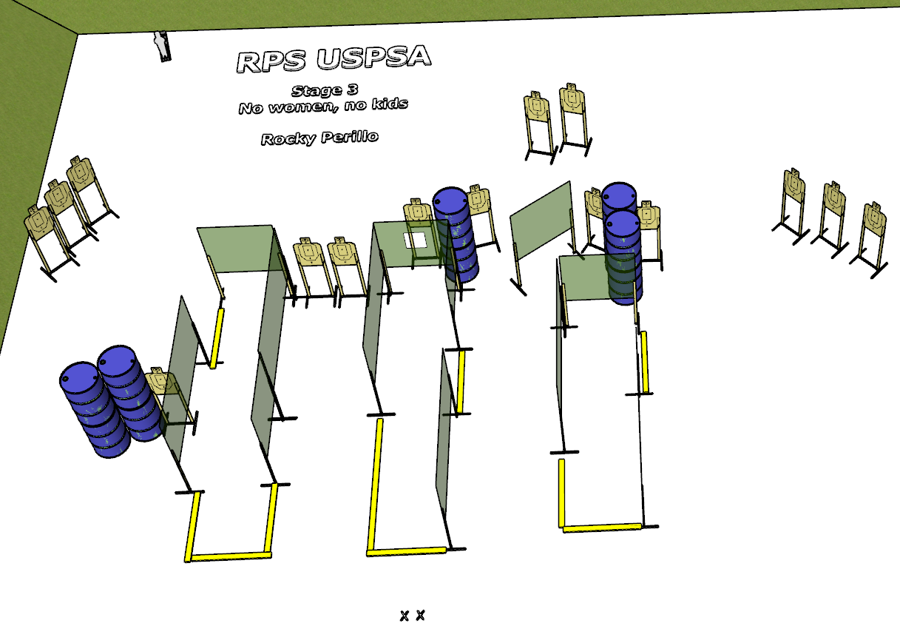

**Written Stage Briefing:**

**Stage 3 – No women, no kids -** is a 31 round, 155 point, Comstock Long Course. There are 15 cardboard targets and 1 steel target. The best 2 hits per cardboard target will be scored. The steel must fall to score.

**Start position** Both feet on the Shooting Sports Innovations Xs, facing generally downrange.

**Handgun: Loaded and holstered.  
PCC: Loaded, stock touching belt.**

On the audible start signal, engage targets from within the shooting area.

**USPSA / NROI Range Commands:**

* Make Ready
* Are you ready?
* Standby
* If finished, unload and show clear.
* If clear, hammer down and holster
* Range is clear

**Setup Notes:**

14 Single Wall Stands

6 Double Wall Stands

6 Full Walls

5 Half Walls

1 Half Port Wall

15 Target stands / 30 target sticks

1 Starting Xs

10+ barrels

